**Dataset Overview:**

The dataset in question pertains to cardiac health, providing insights into potential indicators of heart disease. The columns are as follows:

1. `age`: Age of the patient.

2. `sex`: Gender of the patient.

3. `cp`: Chest pain type, categorized into four distinct types.

4. `trestbps`: Resting blood pressure, measured in mm Hg.

5. `chol`: Serum cholesterol level, quantified in mg/dl.

6. `fbs`: Fasting blood sugar level, indicating if it's greater than 120 mg/dl.

7. `restecg`: Results from resting electrocardiogram, with possible values of 0, 1, or 2.

8. `thalach`: Maximum heart rate achieved during a stress test.

9. `exang`: Indicates if exercise induced angina, a type of chest pain.

10. `oldpeak`: Denotes ST depression (a specific ECG change) observed post-exercise relative to rest.

11. `slope`: Slope of the peak exercise ST segment.

12. `ca`: Number of major blood vessels (ranging from 0 to 3) highlighted during fluoroscopy.

13. `thal`: A categorical variable indicating heart defect type; 0 = normal; 1 = fixed defect; 2 = reversible defect.

**Model Selection and Evaluation:**

For this dataset, we employed the Logistic Regression model, a widely utilized algorithm for binary classification problems. Upon training our model, we used the `classification_report` function from `sklearn` to derive essential metrics.

The label classes in our dataset are balanced, which is an advantageous scenario for most classifiers. Our model demonstrated commendable precision and recall values, at 0.8 and 0.79 respectively.

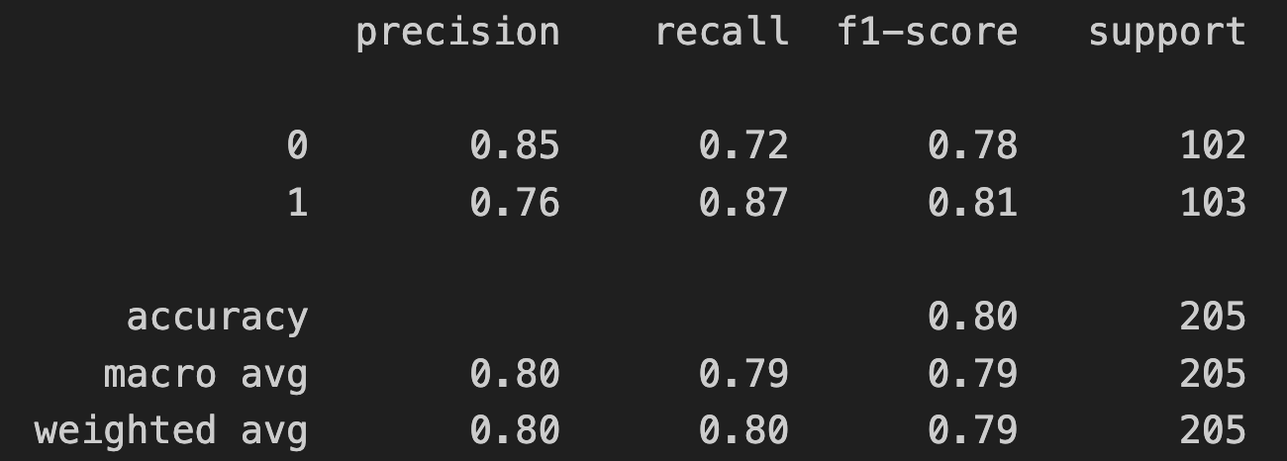

**ROC Curve & AUC:**

The Receiver Operating Characteristic (ROC) Curve is a graphical representation that illustrates a model's ability to distinguish between the positive and negative classes. The Area Under the ROC Curve (AUC) quantifies this ability; a value of 0.88 indicates excellent discriminative power.

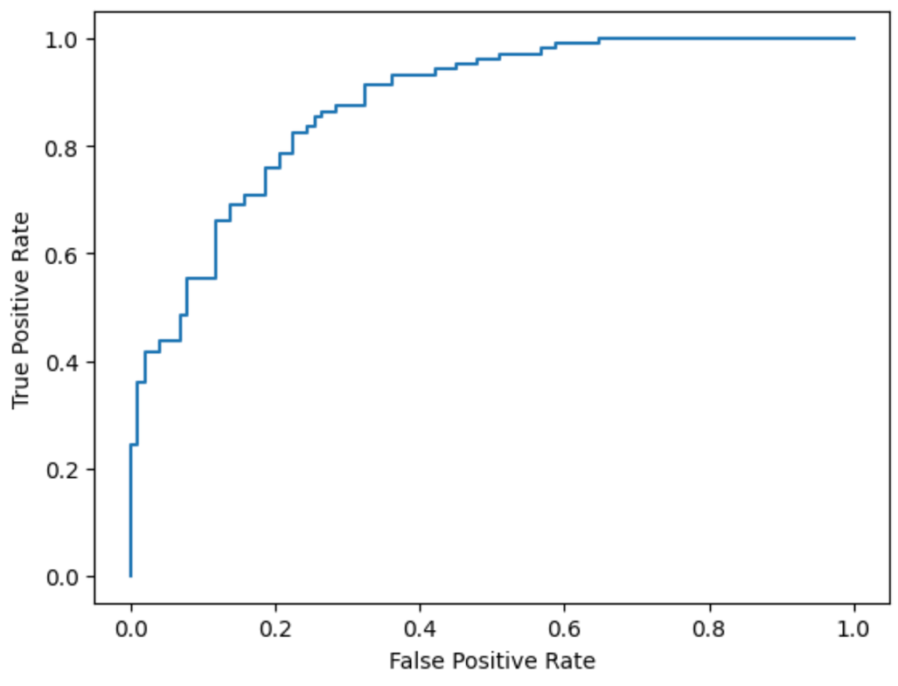

**Precision-Recall AUC:**

Given that our dataset isn't imbalanced, our Precision-Recall AUC closely mirrors our ROC-AUC, scoring 0.88. This further validates the robustness of our model.

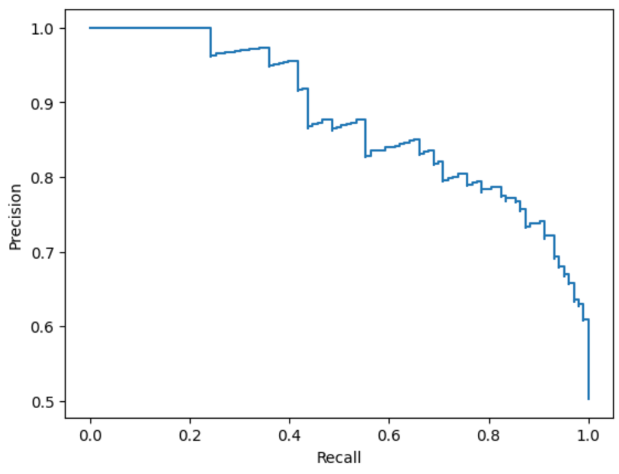

**Conclusions:**

1. **Model Performance:** Both the precision and recall metrics are commendably high, revealing the model's proficiency in correctly identifying positive cases and its effectiveness in labeling actual positive instances.

2. **ROC-AUC**: An AUC score of 0.88 is indicative of an excellent model. A perfect classifier would have an AUC of 1, so 0.88 is a strong result.

3. **PR-AUC**: This further confirms our model's robust performance, especially given the lack of class imbalance.

**Best Metric for Evaluation:**

Given the balanced nature of the dataset, traditional metrics like accuracy, precision, and recall provide a clear view of the model's performance. However, the ROC-AUC and PR-AUC offer a more holistic view, capturing the model's overall ability to distinguish between classes across various thresholds. In this scenario, given the high scores and the balanced dataset, the ROC-AUC serves as an excellent metric to evaluate the model's performance.

Link to the google colab notebook:  
<https://colab.research.google.com/drive/1n2-mUQDI94TehCE5uHfT16OVPnwm46EU?usp=sharing>